**C Programming**

**Basic Programming**

1. Accept two numbers from user and write a C program to print the sum (addition), multiply, subtract, divide and Remainder of two numbers.

2. Accept radius of circle from user and write a program to print the area and circumference of a circle. (take PI as constant)

3. Accept a character from user and write a C program to print the ASCII value of the character.

4. Write a program to accept a number from user and check whether an entered number is even or odd.

5. Accept principal amount, rate of interest and duration from the user and calculate simple interest.

6. Write a program to accept a number from user and display whether entered number is divisible by 100 or not. (hint : use ternary operator)

7. Write a program to accept two numbers from user and swap them without using third variable.

8. Take Ram’s basic salary as input through keyboard. His DA is 40% of basic salary and HRA is 20% of basic salary. Write a program to calculate his gross salary.

9. Accept the distance between two cities (in km) from user. Write a program to convert and print this distance in meters, feet, inches and centimetres.

1. Write a C program to find the sum of first 10 natural numbers.
2. Write a program in C to display the first 10 natural numbers.
3. Write a C program to find the largest of three numbers.
4. Write a program to accept a numbers from user and calculate sum of its digits. (Use % operator)
5. Write a loop from 1 to 100 , print “hello” if number us divisible by 3, print “Hey” if number is divisible by 5 and print “welcome” if the number is divisible by 3 and 5 both.
6. Accept a number from user and print its reverse.
7. Write a C Program to accept a character from user and check it is alphabet or digit.
8. Write a C Program to accept a character from user and check if entered character is vowel or consonant.
9. Write a C Program to convert uppercase character into lower case character and vice versa.
10. Write a C Program to Check Whether the Entered Year is Leap Year or not.
11. Accept a number from user and print it in text.

For ex-

Input – 1234

Output – One Two Three Four

12. Accept a number from user and check whether it is Armstrong number or not.

1. Accept a number from user and print it in text.

For ex-

Input – 1234

Output – One Two Three Four

13. Write a program to read 20 numbers from user and print greatest and lowest number. (Without using array)

14. Consider a currency system in which there are notes of six denominations, namely, Rs. 1, Rs. 2, Rs. 5, Rs.10, Rs. 50 and Rs. 100. If a sum of Rs. N is entered by user. Write a program to compute the smallest number of notes that will combine to give Rs. N.

15. Accept the cost price and sell price of an item from user. Write a program to determine whether the seller has made profit or loss and how much.

16. Accept a number from user and Write a C Program to check if entered number is prime or not.

17.

18. Write a program to check whether a triangle is valid or not, when the three angles of the triangle are entered through the keyboard. A triangle is valid if the sum of all the three angles is equal to 180 degree.

19. Write a program to find absolute value of a entered number.(without using Math.h)

20. Any character is entered through the keyboard; write a program to determine whether the character entered is capital letter, a small case letter, a digit or a special symbol.

21. In boxing the weight class of a boxer is decided as per the following table. Write a program that receives weight as input and prints out the boxer’s weight class.

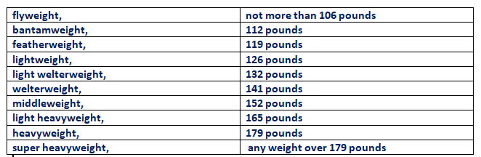

22. Write a program that receives month and date of birth as input and prints the corresponding Zodic sign based on the following.

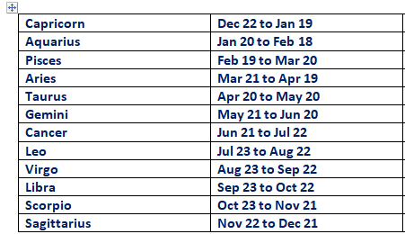

24. Accept two numbers from user. Write a program to find the value of one number raised to the power of another number.

25. Write a program to enter numbers till the user wants. At the end it should display the count of positive, negative and zeros entered.

26. Write a program to print all Armstrong numbers between 1 and 500.

27. Write a program to print all prime numbers from 1 to 300.

28. Write a program to fill the entire screen with a smiling face. (use ASCII value of smiling face i.e 1)

29. Population of a town today is 100000. The population has increased steadily at the rate of 10% per year for last 10 years. Write a program to determine the population at the end of each year in the last decade.

30. Write a program to accept a week in digit from user and display week day in words. If number is not between 0 to 6 display message "Invalid WeekDay".(Use 'switch')

31. Write a program that prints all even numbers between 1 to 20.

32. Write a C program to print all numbers between 1 to 100 which divided by a specified number and the remainder will be 3.

33. Write a menu driven program which has following options:

a. Factorial of a number

b. Prime or not

c. Odd or even

d. Exit

Once a menu item is selected the appropriate action should be taken and once action is finished, the menu should reappear. Unless the user selects the ‘Exit’ option the program should continues to run.

Q1.Accept array elements of 5 integers and find sum of array elements and display it.

Q2.Accept array1 of 5 elements copy it to array 2 display Array 2.

Q3.Write a program to Concatenate two arrays in 3rd array .(for example- if array1 contains 10 elements and array2 contains 5 elements then array 3 should have elements from array 1 followed by elements from array2)

Q4.Accept array elements of 10 integers and store even elements and odd elements from array in separate array called evens and odds. Display both evens and odds array separately.

Q5.Accept an array from user in main and each array element is multiplied by 5.Display entire array .

Q6.Accept an array of 10 elements and accept a number from user search a number in an array and print at which location number is found.if not present in an array then print not found.

Q7.Accept two arrays with 10 elements each and add them and store it in third array and print the third array.

Q8. Rotate the array either in left direction or right direction. depending upon number of times to rotate the array is given .

For example if array is 0f 10 elements and rotate 3 then it’s should rotate 3 times.

Q9.Remove duplicate elements from an array.

**String**

Q1.Accept string from user and print its length.

Q2.Accept string from user and copy the string to another one.

Q3.Accept string from user and send to a function void paliendrome(char [],int Length) which find out whether entered string is paliendrome or not.

(example madam string from left to right and right to left it is exactly same.)

Q4.Accept string from user and send to a function void count(char [],int Length) which find out

Below details -

1. count number ofwords present in the string.

2. count number of occurrences of particular character in the string.

3. count how many spaces are there in given string.